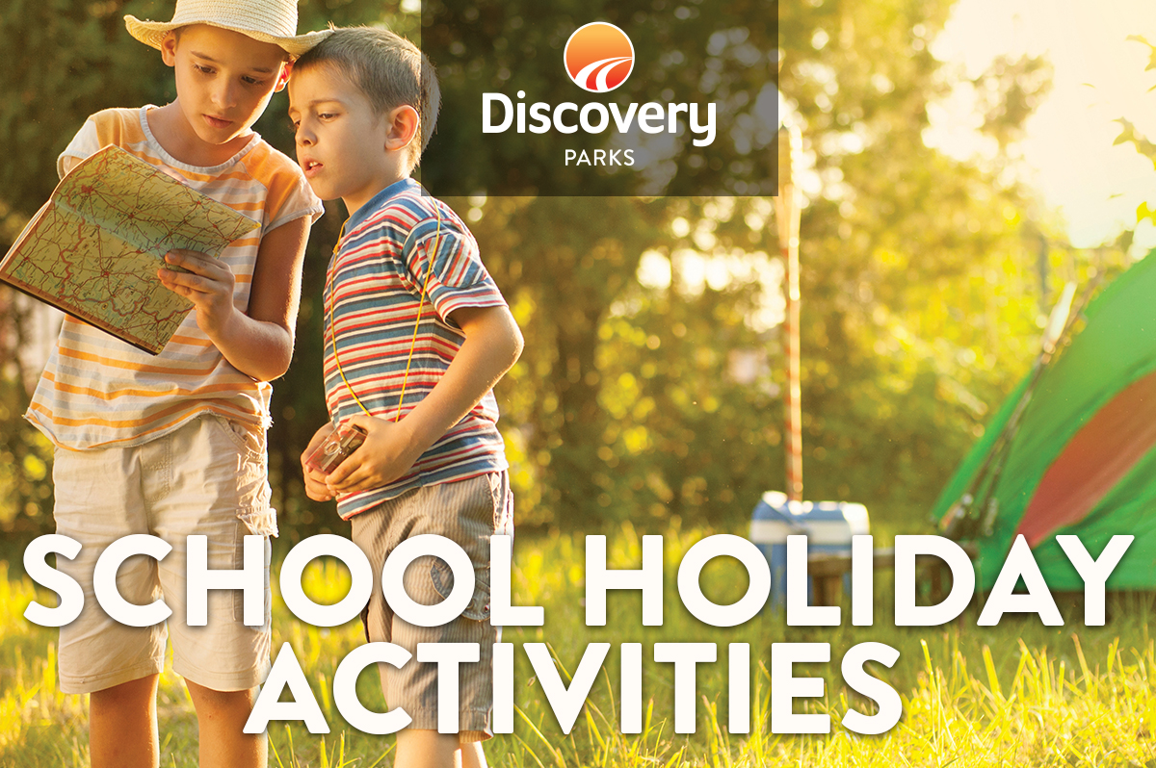
2019 AUTUMN SCHOOL HOLIDAYS
AT DISCOVERY PARKS – BAROSSA VALLEY
Lots and lots of great holiday fun for all the family. From face painting and crazy crafts to movie nights, there’s activities planned throughout the school holidays.
APRIL IS VARIETY MONTH.
DISCOVERY HOLIDAY PARKS HAVE PARTNERED WITH

CHANGING THE LIVES OF CHILDREN IN NEED IN SOUTH AUSTRALIA

DATE | TIME | ACTIVITY | VENUE | COST
Sat 13th | Dusk | Movie Night | Outdoor Cinema
Sun 14th | 11am | Where’s Barry? | Reception
Mon 15th | 11am | Quizz Wizz | Reception
Tues 16th | Dusk | Movie Night | Outdoor Cinema
Wed 17th | 11am | Treasure Hunt | Reception
Thurs 18th | Dusk | Movie Night | Outdoor Cinema
**EASTER LONG WEEKEND**
18th -22nd – Please refer to Easter Program
Mon 22nd | 11am | Where’s Barry? | Reception
Tues 23rd | 10am | Teddy Bear’s Picnic | Stage | $1
 | Dusk | Movie Night | Outdoor Cinema
Wed 24th | 11am | Where’s Barry? | Reception
Thurs 25th |  | Local Anzac Services in the area
Fri 26th | 11am | Where’s Barry? | Reception
Fri 26th | 11am | Where’s Barry? | Reception
 | Dusk | Movie Night | Outdoor Cinema
Sat 27th | Afternoon | Food Vendors | Oval
 | Dusk | Movie Night | Outdoor Cinema
 |  | **STAY & PLAY OPTIONS AVAILABLE – SEE RECEPTION FOR MORE DETAILS
 |  | All activities subject to change

