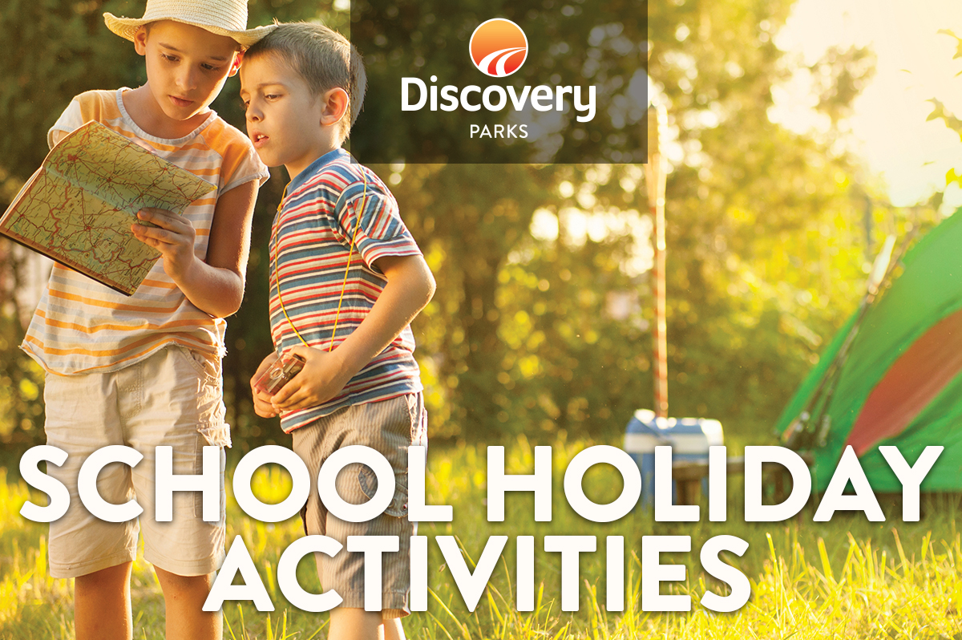
2019 AUTUMN SCHOOL HOLIDAYS
AT DISCOVERY PARKS – EMERALD BEACH
Lots and lots of great holiday fun for all the family. From Crazy crafts to movie nights, there’s activities planned throughout the school holidays.

DATE | TIME | ACTIVITY | VENUE | COST
15/4/19 | 10.30am - 12.30pm | Art and Craft activities | Movie Room | Free
15/4/19 | 6pm | Family Movie | Movie Room | Free
16/4/19 | 10.30am - 12.30pm | Chalk Graffiti and games | Movie Room | Free
16/4/19 | 1.30pm - 2.30pm | Surf Lessons  Exclusive for park guests | Reception | $20
16/4/19 | 6pm | Family Movie | Movie Room | Free
17/4/19 | 11am | Pizza making with Matt.  Make your own lunch  Please book by Monday lunchtime | Emerald Beach Pizza | $15 per person
17/4/19 | 6pm | Family Movie | Movie Room | Free
18/4/19 | 10.30am - 12.30pm | Chocolate coconut balls | Movie Room | $2.00
18/4/19 | 1.30pm - 2.30pm | Surf Lessons  Exclusive for park guests | Reception | $20
18/4/19 | 6pm | Family Movie | Movie Room | Free
19/4/19 | 10.30am - 12.30pm | Fishing Simulator | Movie Room | Free
19/4/19 | 6pm | Family Movie | Movie Room | Free
20/4/19 | 10am | Booklet of possible tasks | Collect from office | Free
20/4/19 | 6pm | Family Movie | Movie Room | Free
21/4/19 | 11am | Easter Bunny arrives | Meet at back camp kitchen | Free
21/4/19 | 11.10am | Easter Egg hunt |  | Free
21/4/19 | 6pm | Family Movie | Movie Room | Free
22/4/19 | 10.30am | Colouring competition | Office | Free
22/4/19 | 6pm | Family movie | Movie Room | Free
23/4/19 | 10.30am - 12.30pm | Cookie decorating | Front camp kitchen | $2.00
23/4/19 | 1.30pm - 2.30pm | Surf Lessons  Exclusive for park guests | Reception | $20.00
23/4/19 | 6pm | Family Movie | Movie room | Free
24/4/19 | 11am | Pizza making with Matt.  Make your own lunch  Please book by Monday lunchtime | Emerald Beach Pizza | $15 per person
24/4/19 | 1.30pm - 2.30pm | Surf Lessons  Exclusive for park guests | Reception | $20
24/4/19 | 6pm | Family Movie | Movie Room | Free
25/4/19 | 10.30am - 12.30pm | Family Games | Jumping Pillow | Free
25/4/19 | 6pm | Family Movie | Movie Room | Free
26/4/19 | 10.00am - 12.00pm | Chalk Graffiti and games | Movie Room | Free
26/4/19 | 1.30pm - 2.30pm | Surf Lessons  Exclusive for park guests | Reception | $20
26/4/19 | 6pm | Family Movie | Movie Room | Free
27/4/19 | 10am | Booklet of possible tasks | Collect from office | Free
27/4/19 | 6pm | Family Movie | Movie Room | Free

