[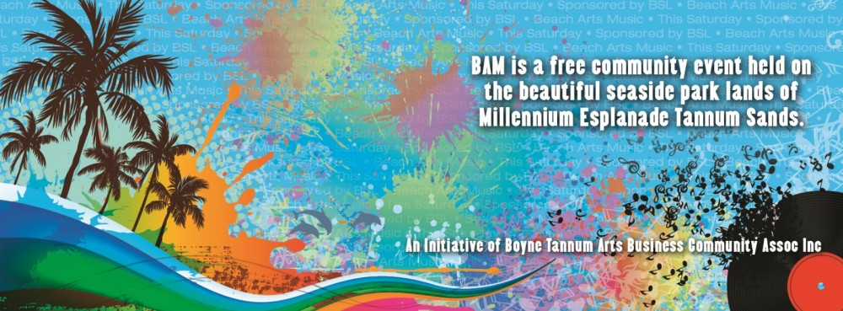](https://www.google.com.au/url?sa=i&rct=j&q=&esrc=s&source=images&cd=&cad=rja&uact=8&ved=2ahUKEwiDmoq-7dbZAhUCXrwKHdFgAxAQjRx6BAgAEAY&url=https://www.gladstonelife.com/bam-markets-beach-art-music/&psig=AOvVaw3jrpJiFuSMSKviNokAtCXi&ust=1520396742203146)

JOIN US ON THE 1ST SATURDAY OF EACH MONTH FOR THE BOYNE TANNUM BEACH ARTS & MUSIC MARKETS

COME & SPEND THE WEEKEND

DISCOVERY PARKS TANNUM SANDS