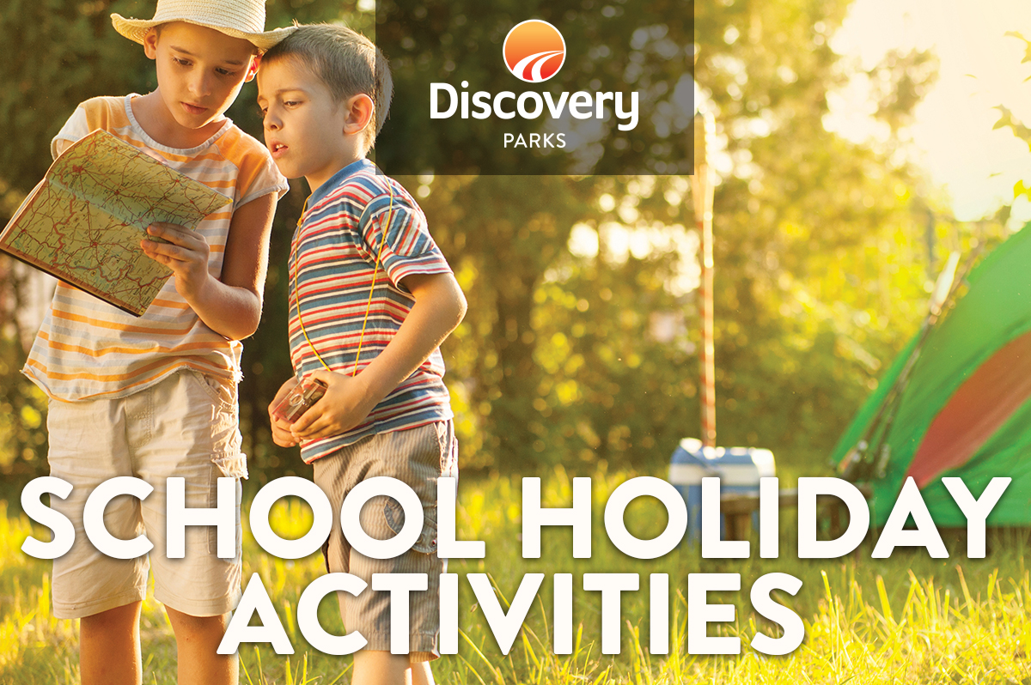
2017 AUTUMN SCHOOL HOLIDAYS
AT DISCOVERY PARKS – ROBE
Lots and lots of great holiday fun for all the family. From face painting and crazy crafts to movie nights, there’s activities planned throughout the school holidays.

DATE | TIME | ACTIVITY | VENUE | COST
Sat 13th April | All Day | Colouring in Comp, winner drawn Sat Morning | Get your colouring in pages from the Office | Free
Sun 14th | 7pm | Big Screen Movie | Games Room | $2
Mon 15th | All Morning | Find Lucy the Lobster, let Office Staff know where Lucy is hidden, and you will go into the draw to win a FREE 1hr pedal bike ride (Drawn at 3pm) | Hidden somewhere in the park | Free
Tues 16th | Until 3pm | Quiz Day, Winner will receive a FREE 1hr pedal bike ride (Drawn at 3pm) | Collect your entries from the Office | Free
Thurs18th | All Morning | Find Lucy the Lobster, let Office Staff know where Lucy is hidden, and you will go into the draw to win a FREE 1hr pedal bike ride (Drawn at 3pm | Hidden somewhere in the park | Free
Fri 19th | All Day | Colouring in Comp, winner drawn Sat Morning | Get your colouring in pages from the Office | Free
Sat 20th | 7:30-9pm | Kids Disco. Come join us and dance the night away, you may receive a prize! | Games Room | $2
Sun 21st | 9:30am | Easter egg Hunt | Meet at the Jumping Pillow | Free
Mon 22nd | All Morning | Find Lucy the Lobster, let Office Staff know where Lucy is hidden, and you will go into the draw to win a FREE 1hr pedal bike ride (Drawn at 3pm) | Hidden somewhere in the park | Free
Tues 23rd | Until 3pm | Quiz Day, Winner will receive a FREE 1hr pedal bike ride (Drawn at 3pm) | Collect your entries from the Office | Free
Thurs 24th | All Morning | Find Lucy the Lobster, let Office Staff know where Lucy is hidden, and you will go into the draw to win a FREE 1hr pedal bike ride (Drawn at 3pm) | Hidden somewhere in the park | Free
Fri 25th | All Day | Colouring in Comp, winner drawn Sat Morning | Get your colouring in pages from the Office | Free
Sat 26th | 7pm | Movie Night | Games Room | $2

