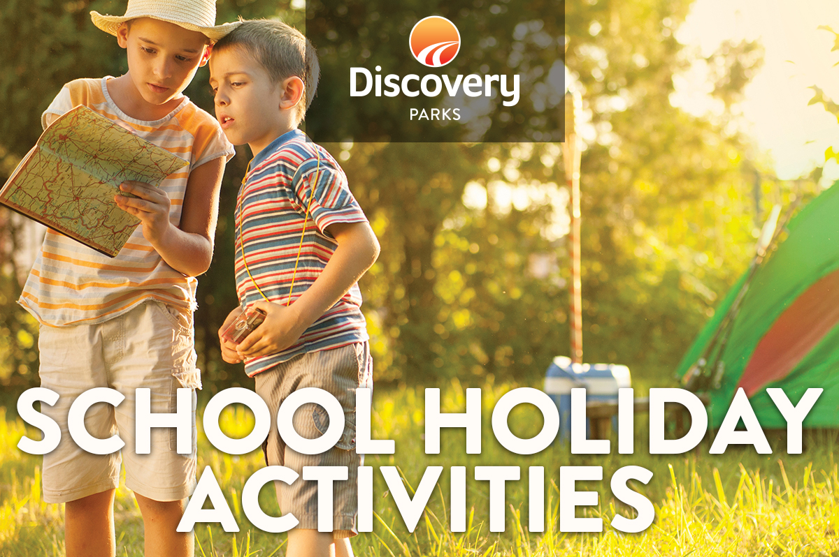
2019 AUTUMN SCHOOL HOLIDAYS
AT DISCOVERY PARKS – CLARE
Lots and lots of great holiday fun for all the family. From face painting and crazy crafts to movie nights, there’s activities planned throughout the school holidays.

DATE | TIME | ACTIVITY | VENUE | COST
15.04.19 | 8.30am-5am | ALL DAY TREASURE HUNT | SEE RECEPTION | FREE
16.04.19 | From 7.30pm | MOVIE NIGHT | GRASSED AREA | FREE
17.04.19 | 6.30PM | ROAST MEAT ROLL & GRAVY NIGHT | BBQ AREA | $7 PER ROLL
18.04.19 | 8.30am-5pm | ALL DAY TREASURE HUNT | SEE RECEPTION | FREE
20.04.19 | From 6.30pm | MOVIE NIGHT | GRASSED AREA | FREE
21.04.18 | 8.30am-5pm | ALL DAY TREASURE HUNT | SEE RECEPTION | FREE
24.04.18 | 6.30pm | ROAST MEAT ROLL & GRAVY NIGHT | BBQ AREA | $7 PER ROLL
26.04.18 | From 6.30pm | MOVIE NIGHT | GRASSED AREA | FREE
 |  | ALL ACTIVITIES ARE SUBJECT TO WEATHER AND INTEREST
 |  | PLEASE ADVISE RECEPTION STAFF IF YOU ARE INTENDING TO JOIN IN WITH THESE ACTIVITIES

