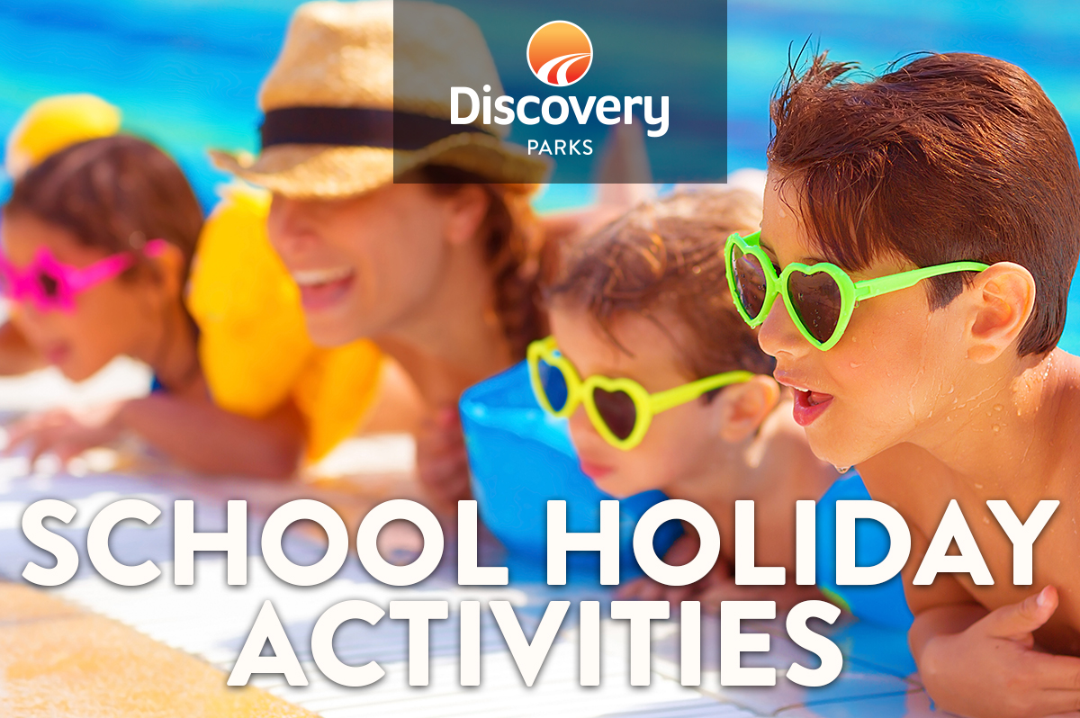
2018/19 SUMMER SCHOOL HOLIDAYS
AT DISCOVERY PARKS – TOWNSVILLE
Lots and lots of great holiday fun for all the family. From face painting and crazy crafts to movie nights, there’s activities planned throughout the school holidays.

DATE | TIME | ACTIVITY | VENUE | COST
22ND DEC | 10AM | TREASURE HUNT | RECEPTION | FREE
28TH DEC | 8AM | PANCAKE BREAKFAST | CAMP KITCHEN | $2 PER PLATE
1ST JAN | 10AM | COLOURING COMPETITION | RECEPTION | FREE
3RD JAN | 6PM | MOVIE POPCORN AND DRINK | VIP ROOM | $5 PER PERSON
4TH JAN | 8AM | PANCAKE BREAKFAST | CAMP KITCHEN | $2 PER PLATE
8TH JAN | 10AM | TREASURE HUNT | RECEPTION | FREE
10TH JAN | 6PM | MOVIE POPCORN & DRINK | VIP ROOM | $5 PER PERSON
11TH JAN | 6PM | PANCAKE BREAKFAST | CAMP KITCHEN | $2 PER PLATE
12TH JAN | 10AM | COLOURING COMPETITION | RECEPTION | FREE
17TH JAN | 6PM | MOVIE POPCORN & DRINK | VIP ROOM | $5 PER PERSON
18TH JAN | 8AM | PANCAKE BREAKFAST | CAMP KITCHEN | $2 PER PLATE
19TH JAN | 10AM | TREASURE HUNT | RECEPTION | FREE
24TH JAN | 8AM | MOVIE POPCORN AND DRINK | VIP ROOM | $5 PER PERSON
26TH JAN | 6PM | SAUSAGE SIZZLE | CAMP KITCHEN | GOLD COIN DONATION

