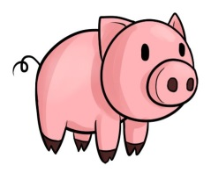
ROAST MEAT ROLLS
& GRAVY NIGHT
EVERY WEDNESDAY
6.30PM-BBQ AREA
$7 PER ROLL
LOVINGLY COOKED IN THE WEBERS
(INC ONIONS & CONDIMENTS)
BYO PLATE, CHAIRS & DRINKS
ALL PROFITS TO VARIETY
Featuring wine tastings from local winery
